CPU mem:

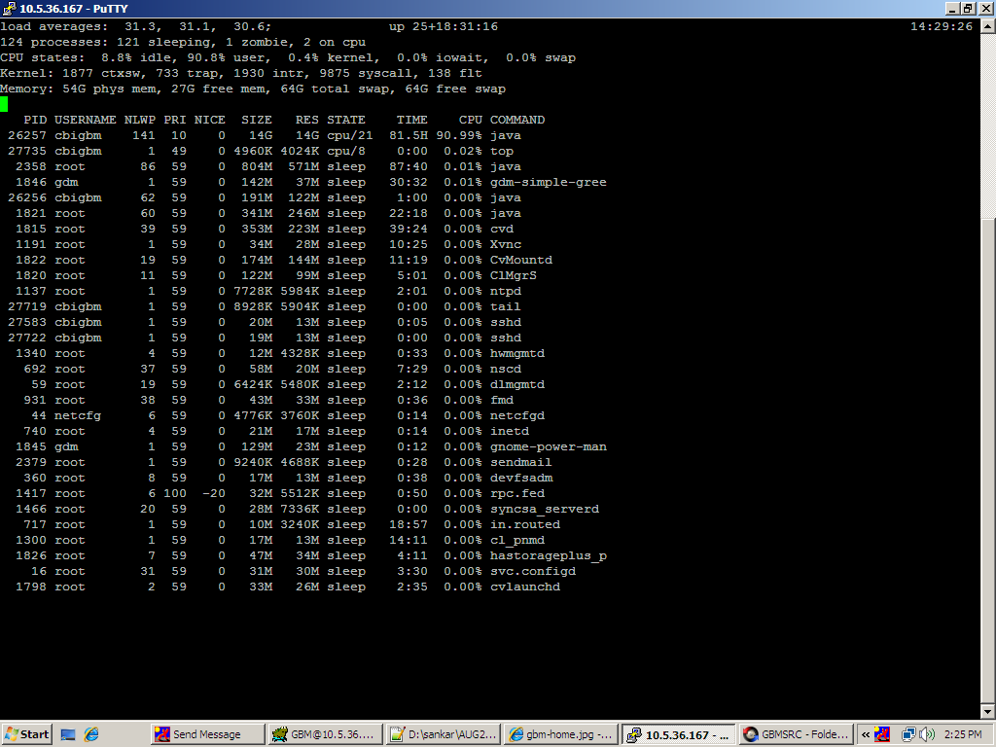

For top command result,Here 26257 pid id related to RESIN taking more utilization which has the screen shot mentioned below.

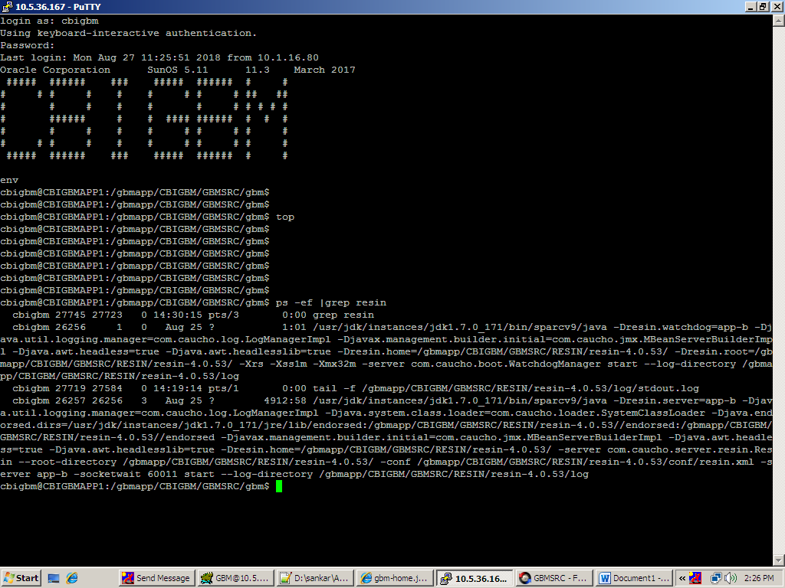

Result for prstat –a command :

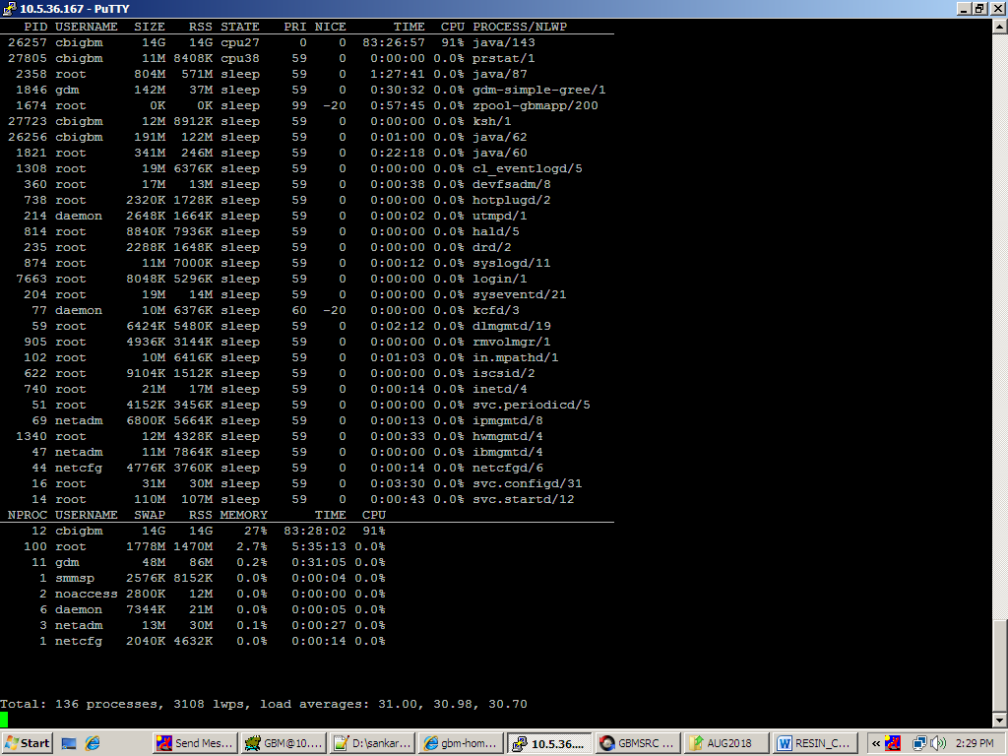

Resin daily performance issue and resin process high CPU utilization issue